Error Handling Helpline

Group Members
- Reece Willoughby
- Alexi Colley
- Nawaraj Budhathoki
- Roman Reshetniak
GitHub: reece
https://github.com/WILR96/ErrorHandlingHelpline
Task board: reece
https://github.com/users/WILR96/projects/1
Project Idea Summary Reece
This project is a Debugging & Programming Help platform that lets students post technical programming problems and receive help from the community.
Users can share error messages, code snippets and environment issues. Others can respond with explanations and debugging guidance.
The platforms’ goal is to promote collective learning, support and help in developing critical thinking skills. !!!!!NEEDS TO BE REFINED!!!!

Core User Stories
Create Help Post
As a user, I want to create a help request, so that I can receive assistance with a coding problem.
Acceptance Criteria:
- User must be logged in.
- User can add title and description.
- Optional code/image upload.
- Post appears in main feed with any files added.
View Posts
As a user, I want to browse help posts, so that I can find problems I can assist with.
Acceptance Criteria:
- All posts are displayed in the main feed.
- Each post shows title, author and timestamp.
- Posts are ordered by most recent by default.
Answer a Post
As a user, I want to respond to a help request, so that I can assist another student.
Acceptance Criteria:
- User must be logged in.
- User can submit a written response.
- Response appears under the original post.
- Response shows author and timestamp.
Mark Answer as Solved
As the original poster, I want to mark an answer as solved, so that helpful responses are recognised.
Acceptance Criteria:
- Only the original poster can mark an answer as solved.
- Only one answer can be marked as solved.
- Solved answer is visually highlighted.
- Reputation points are awarded to the responder.
Mark Answer as Helpful
As a user, I want to mark an answer as helpful, so that quality contributions are rewarded.
Acceptance Criteria:
- User must be logged in.
- A user can only mark an answer helpful once.
- Helpful count updates immediately.
- Reputation points are awarded to the responder.

Gamification User Stories
Earn Reputation
As a contributor, I want to earn reputation points when my answers are marked as solved or helpful, so that my contributions are recognised.
Acceptance Criteria:
- Reputation increases when answer is marked solved.
- Reputation increases when answer is marked helpful.
- Reputation cannot exceed daily cap.
- Updated reputation is reflected immediately on profile.
View Reputation
As a user, I want to see my reputation score and role title, so that I can understand my standing within the community.
Acceptance Criteria:
- Reputation score is visible on user profile
- Role title is displayed based on reputation
- Role updates automatically when threshold is reached
Automatic Role Progression
As a contributor, I want my role (e.g., Contributor, Trusted Helper, Community Mentor) to update automatically based on my reputation, so that mentorship emerges naturally.
Acceptance Criteria:
- The system assigns a role based on predefined reputation thresholds
- Role updates automatically when a user reaches a new threshold
- Role changes do not require manual approval
- The updated role is displayed immediately on the user’s profile
- The updated role is displayed next to the user’s username in posts
- Role cannot be manually edited by the user
View Other Users’ Reputation
As a user, I want to see reputation and role titles next to usernames in posts, so that I can identify experienced contributors.
Acceptance Criteria:
- Role title is displayed next to username
- Reputation score is displayed next to username
- Display updates automatically when reputation changes
Earn Badges
As a user, I want to earn badges for milestones (e.g., first solved answer), so that positive behaviour is encouraged.
Acceptance Criteria:
- Badge is awarded when milestone is reached
- Badge is visible on user profile
- Badge remains permanently once earned
Private Messaging
As a user, I want to be able to message other users privately for help, so that I can receive more detailed guidance outside of a public thread.
Acceptance Criteria:
- User must be logged in to send or receive messages.
- User can send a private message to another registered user.
- Recipient receives a notification of a new message.
- Messages are only visible to the sender and recipient.
- Message history is stored and viewable within a conversation thread.
- Users cannot message themselves.
- Users can report or block inappropriate messages.

Moderation User Stories
Report Content
As a user, I want to report inappropriate or low-quality content, so that the community remains supportive and safe.
Acceptance Criteria:
- Report button is visible on posts and answers
- User must be logged in to report
- Report is recorded in the system
- Administrator can review reported content
Daily Reputation Cap
As a system administrator, I want to limit daily reputation gain, so that users cannot exploit the scoring system.
Acceptance Criteria:
- The system defines a maximum amount of reputation that can be earned per user per 24-hour period
- Reputation points stop increasing once the daily cap is reached
- The cap resets automatically after 24 hours
- Users cannot bypass the cap through multiple posts or repeated interactions
- The system still records helpful or solved actions even if no additional reputation is awarded
- The cap value can be configured by an administrator
Delete Posts
As a system administrator, I want to delete inappropriate or low-quality posts, so that the community remains safe, respectful, and supportive.
Acceptance Criteria:
- Administrator must be logged in with admin privileges.
- Administrator can delete any post from the system.
- Deleted posts are removed from the public feed.
- Associated answers/comments are also removed or handled appropriately.
- The system records that the post was deleted.

Use Case Diagram
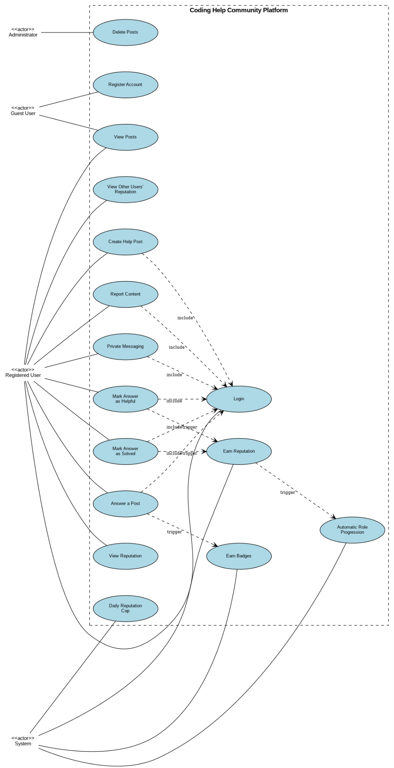

Overview
This diagram outlines the key actors, use cases, and automated system behaviours for the Coding Help Community Platform — an error handling helpline where junior developers seek help and experienced engineers provide guidance.
Actor
Actor | Key Capabilities
Guest User | Register account | View posts (read-only)
Registered User | Login | Create help post | Answer posts | Mark as solved/helpful | View reputation | Private messaging | Report content
Administrator | Delete posts | Review reported content | Configure system settings
System | Auto-calculate reputation | Role progression | Award badges | Enforce daily reputation cap

Use Cases

# | Use Case | Category
1 | Register Account | Authentication
2 | Login | Authentication
3 | Create Help Post | Content Management
4 | View Posts | Content Management
5 | Answer a Post | Content Management
6 | Mark Answer as Solved | Content Management
7 | Mark Answer as Helpful | Content Management
8 | Earn Reputation | Gamification
9 | View Reputation | Gamification
10 | Automatic Role Progression | Gamification
11 | Earn Badges | Gamification
12 | Private Messaging | Communication
13 | Report Content | Moderation
14 | Delete Posts | Moderation
15 | Daily Reputation Cap | Moderation

Key Relationships

Include  (Login required) | Create Post | Answer Post | Mark Solved | Mark Helpful | Private Messaging | Report Content
Triggers  (automated) | Mark Solved -> Earn Reputation -> Role Progression | Answer Post -> Earn Badges

Reputation & Role Progression

Solved answer | +10 points
Helpful answer | +5 points
Daily cap | Max 100 points per day (resets every 24 hrs)
Contributor | 0 - 99 points
Trusted Helper | 100 - 499 points
Community Mentor | 500+ points

User Flow Examples

New User | Register -> Login -> View Posts -> Answer Post -> System awards Reputation & 'First Answer' badge
Posting a Problem | Login -> Create Help Post -> Community responds -> Mark Answer as Solved -> System awards Reputation & checks Role Progression
Moderation | User reports content -> Admin reviews -> Admin deletes post if violation confirmed

Implementation Notes

- All authenticated actions must verify user session/token.
- Reputation, badges, and role updates should run asynchronously to avoid blocking.
- Reputation calculations must be atomic to prevent race conditions.
- Rate-limit Report Content to prevent abuse.
- All admin actions should be logged for audit trail.

Wireframes
!!!!ADD HERE!!!!

Activity Diagrams

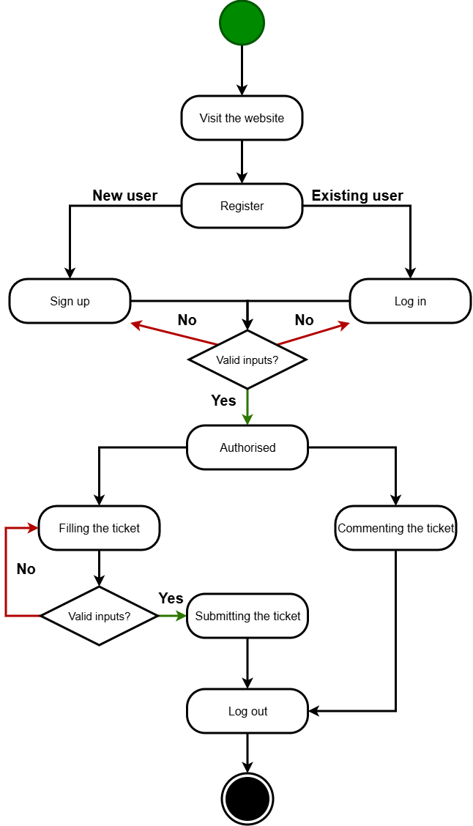

Other artefacts may be included such as sequence diagrams, ERD diagram,
class diagram, designs, colour schemes
!!!!ADD HERE!!!!

Colour Schemes
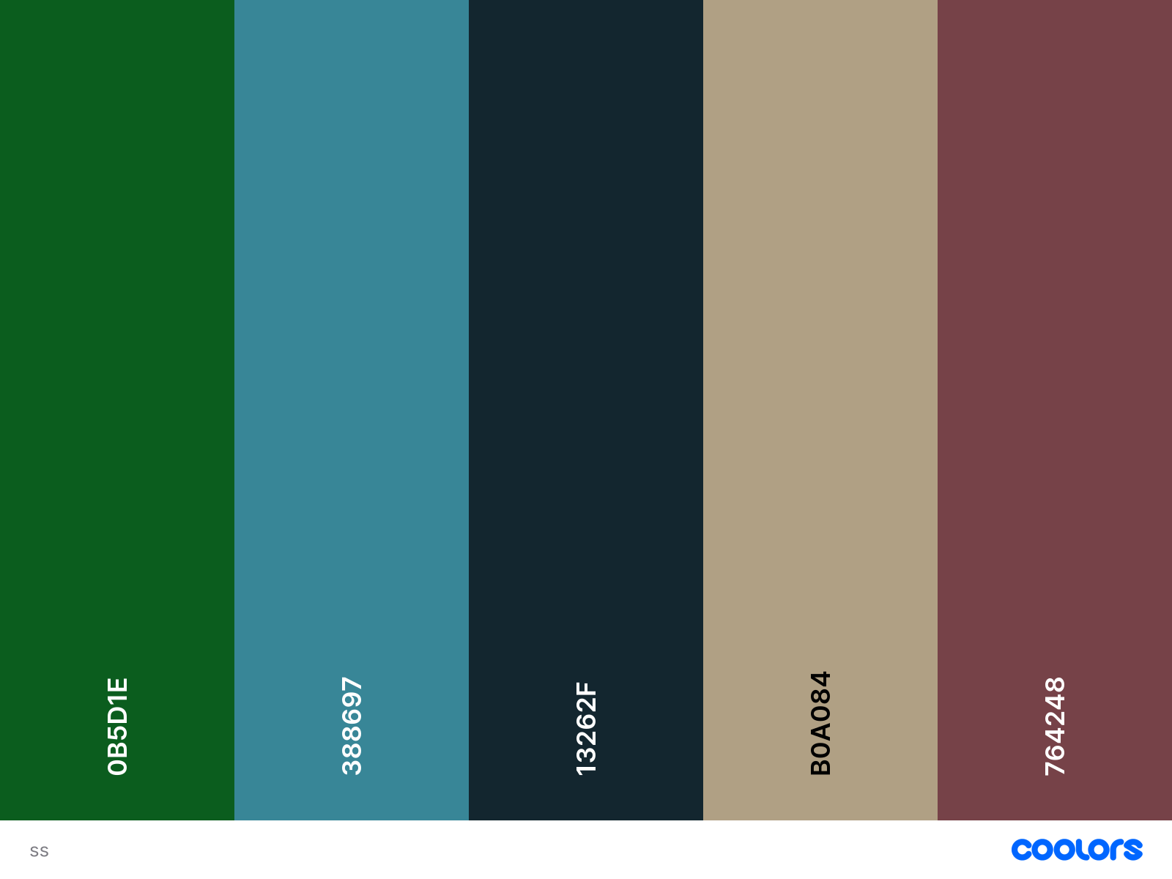

Kanban board
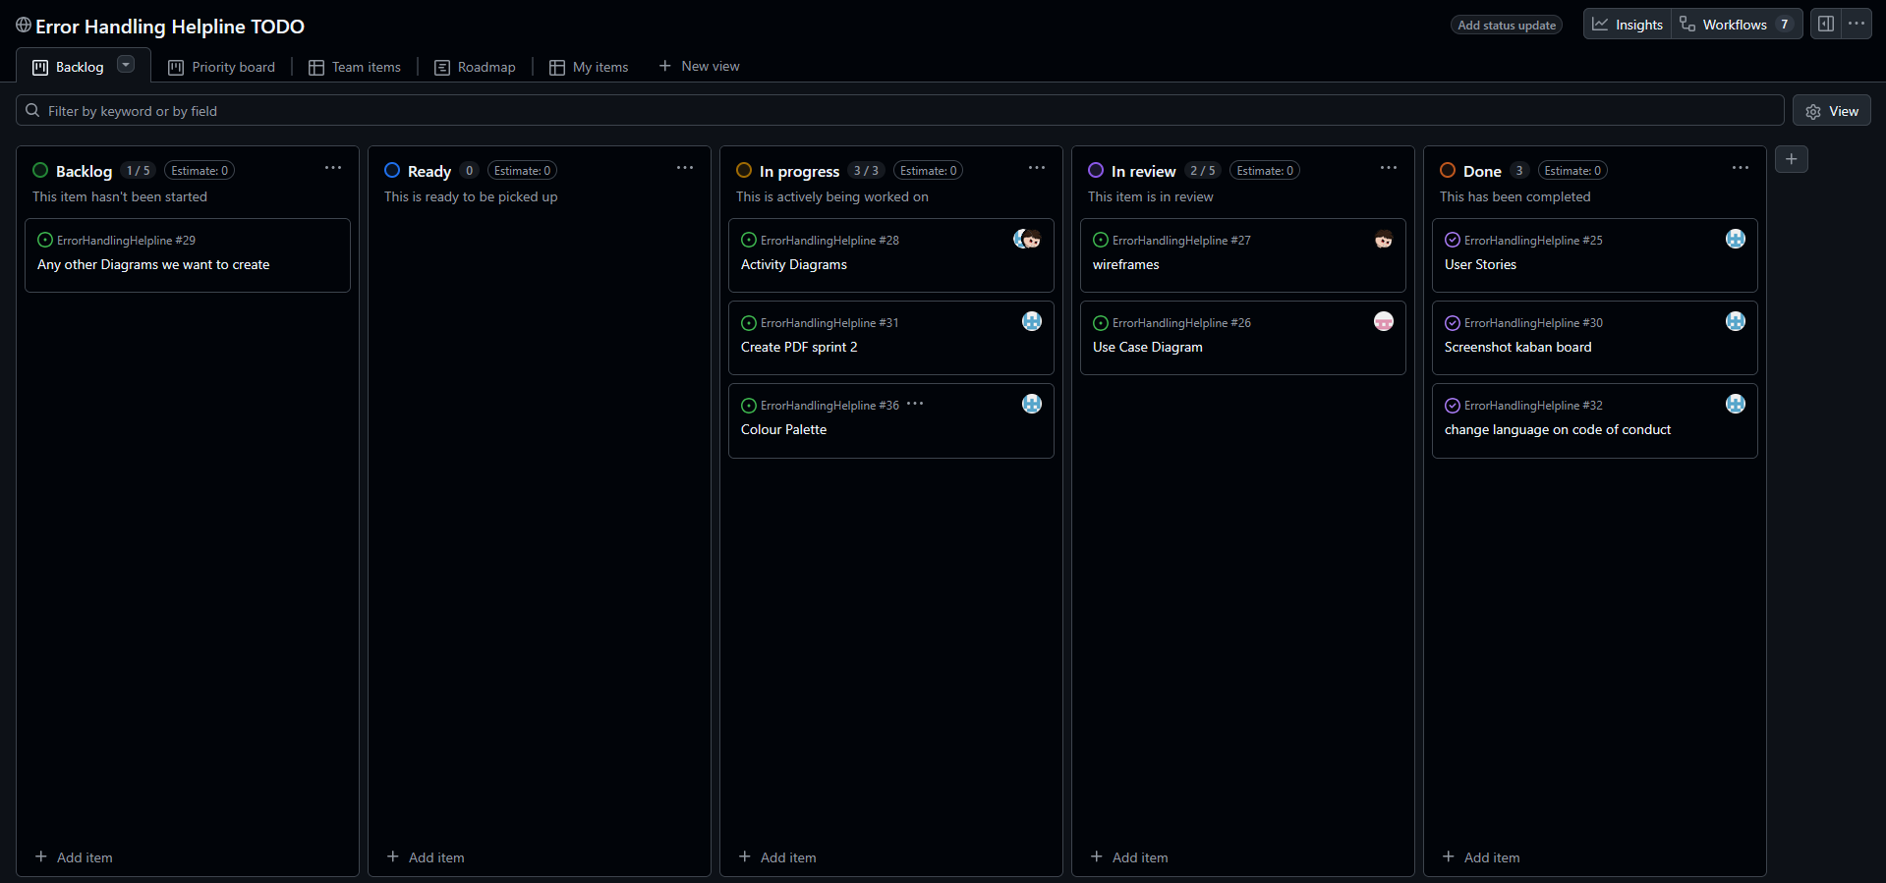

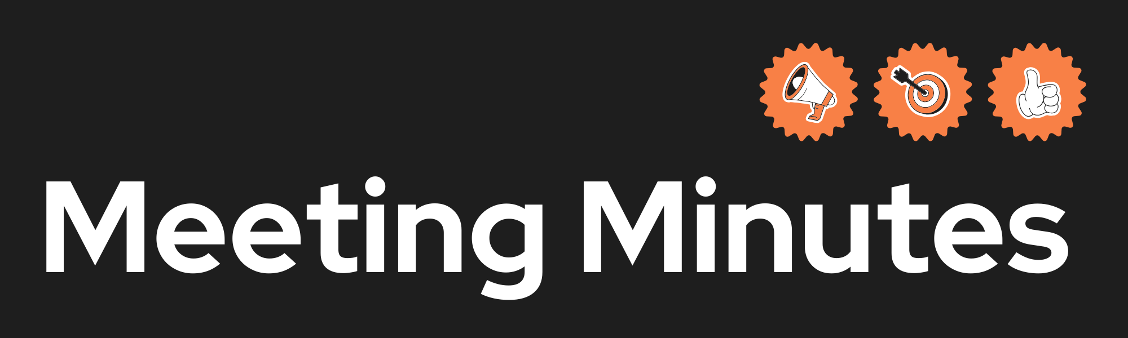
Date and Time | 10/02/2026
Project Name | Error Handling Helpline
Meeting Goal | - Define some new features that relate to the coursework brief  - Assign jobs for sprint 2
Facilitator | Reece Willoughby
Note taker | Reece Willoughby
Attendees | Reece Willoughby  Alexi Colley  Nawaraj Budhathoki
Roundtable Updates (each group member to contribute) | Reece suggested that we talk about the different features we should have in the project.
Discussion points | Social messaging  Time trials – for error handling  Liking things (like comments)  Give awards to smart comments.  Give variable points to users when commenting  Upload images / programming files  Leaderboards – Special rewards for top 10
Actions (list tasks and assign a group member) | Distributed all tasks.

Nawaraj

